You have made it into the laptop! You see the file on the desktop and click on it. There seem to be 4 different evil plans in the file, so you are not sure which one is the true plan. There is however a remote control on the desk that will help you work out the correct plan.

Plans on the file:

Sneak into Ivanheidel at dawn to hurt villagers.

Control Dagenburg's bridge and steal gold from boats.

Meet in Shieldhaven for an attack on the king.

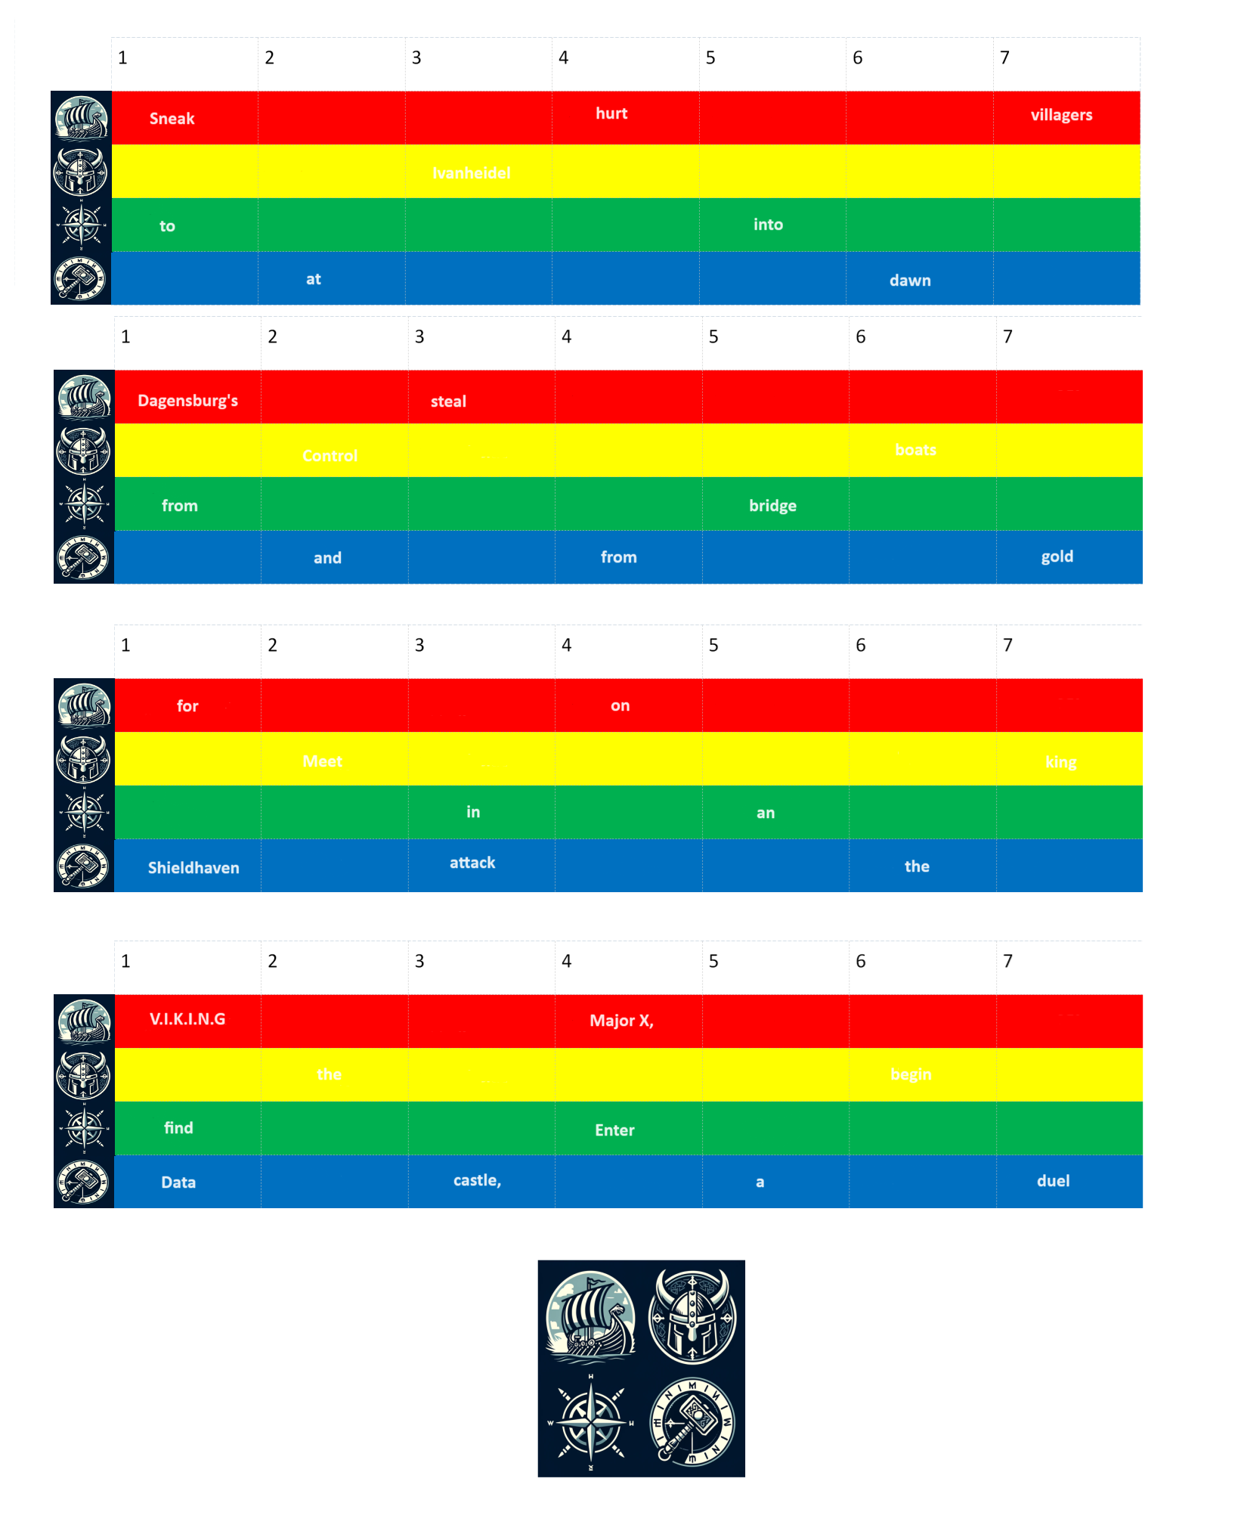Enter the Data V.I.K.I.N.G castle, find Major X, begin a duel.

Find out which plan is correct by clicking the button on the device that matches up to the colour/emblem of each word in each plan.

When you enter the correct sequence, you will be told that you have successfully found the evil plan, and you can text Major X so that he can notify MI5.







For example:

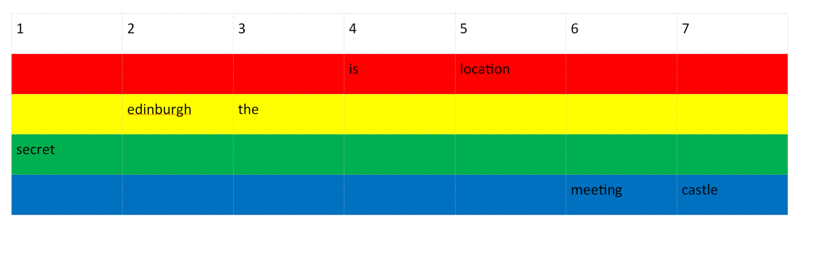The sentence: "The secret meeting location is Edinburgh Castle" would give a colour order of:

Yellow, green, blue, red, red, yellow, blue.